I Hate Learning

On Climbing

Zoe's avatar

[Zoe](https://substack.com/@zoeffc)

May 23, 2025

Dear Reader,

You have known me almost a year now, but you don’t know one crucial thing about me: I hate learning.

Well, “I hate learning” is more of a go-to mantra for me. It is a stand-in for *“this is hard”* and *“I don’t like being bad at things”* or even *“why am I not already good at this?”*. So yes, I will claim it — I hate learning.

Before I go any further — let’s do the housekeeping.

First, if you are not already a subscriber and you resonate with any of the following descriptors, consider joining the cooperative: (1) Early-career professional; (2) Feminist; (3) Do-gooder; (4) Former Gifted Kid; (5) Overachiever; or (6) Capitalism-hater.

Subscribed

Second, if you like what I am saying and it makes you think of someone in your family/office/friend group, send it their way.

[Share Femme Futures Cooperative](https://femmefuturescooperative.substack.com/?utm_source=substack&utm_medium=email&utm_content=share&action=share)

Third, I say some personal and vulnerable shit every week. Say some vulnerable shit back. It’s called a community.

[Leave a comment](https://femmefuturescooperative.substack.com/p/i-hate-learning/comments)

Okay — back to it.

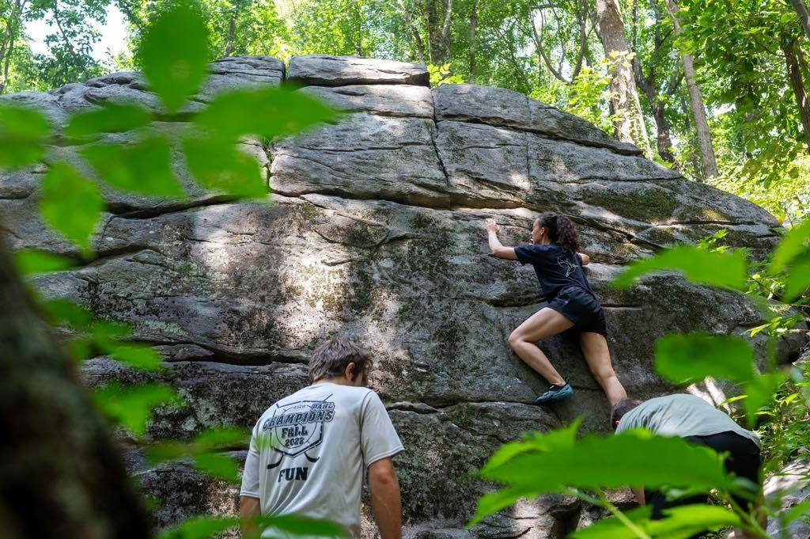

it’s me!

My issue is really with the *learning curve*. If learning was a constant improvement, I think that I could actually get behind it. I am looking for a clear y=mx+c type curve. Instead, it is some messed up scatter-plot graph that jumps and dips and … plateaus.

Please, if there is a higher power, grant me a life without learning plateaus. I promise that I will do the work to get better, but I want to see the progress. I want to know that what I am doing is worth it. This is one of the things that I have spent the last year struggling with in my non-work-life.

I started bouldering about two and a half years ago. Bouldering has been vital to me growing into an adult and out of my adolescence. When I started climbing, I was awful at it, though not so awful that I never wanted to try it again (for that story, you will need to ask me about pole dancing). Climbing required upper-body strength that I absolutely did not have at the time, but it also required creative problem-solving and the niggling voice at the back of your mind that says, “If I just try this thing one more time, I know I’ll get it.” I rode that niggling through my first year, watching myself race through grades and get seriously buff.

At the end of 2023, I was locking in on my first v5 projects. They were daunting, but I wanted to keep improving. I was hooked on the high of that first learning burst. That is, of course, when the plateau hit. The v5s were not doable for me — I stopped trying them. Then I stopped trying v4s when those felt too hard. Then I was back at v3, a grade I had first hit about six months into my climbing journey, but was now stuck on a year later. The excitement around going to the gym three times a week was fading, but at that point, all of my friends were there, so I kept going.

Let me spoil the ending: I still have not done a v5.

I feel a lot of shame around that. It’s silly because it is an arbitrary goal, and perhaps my goal should instead be on showing up, or embracing being bad at something. Nevertheless, I feel like I let myself down and I let down every one of my friends who has been rooting for me. That shame really kicked in about six months ago. It was this shame that made me pull away from my closest friends as well as the larger climbing community.

It’s funny writing about this as though it’s in the past. It’s not. I was whining to my boyfriend about this just last night, leading to some contemplation about why I am even doing this.

Here’s the thing: learning is never going to be easy for me. I am afraid that maybe it is easy for other people, or maybe we are all particularly adept at learning specific things. Not only that, but learning may be so hard that it keeps you (me—I mean me) from starting a thing, that it wrecks your self-image, or that it isolates you from your community. I’m not saying that it is healthy, but I am saying that it is normal.

I guess I am also asking that you reflect when learning gets hard. Why did you want to do this in the first place? Why did you want to do this yesterday? What does it cost you to suck at this thing?

My wish for this community is that we acknowledge the challenge of learning new things, be them hobbies or just learning how to exist as an adult in the world, and we reflect on the value of the effort and then we either keep pushing, or we let it go.

Best,

Zoe

P.S. When I sat down to write this, it was not supposed to be all about climbing. It seems however, that when something feels big and heavy to me in my real life, that it often demands to be processed through writing. That being said, I have more to say about my hatred of learning, so I hope you are interested to hear more.

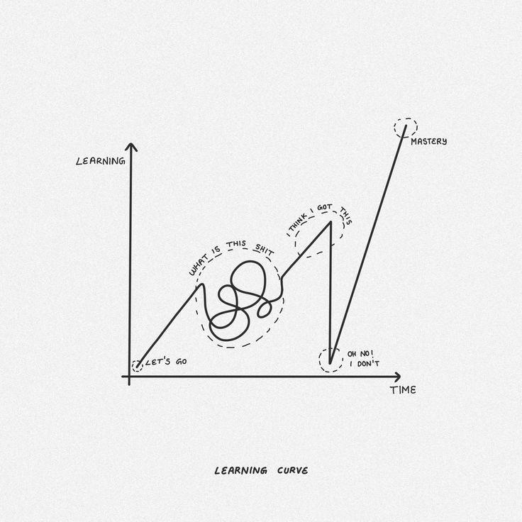

artist unknown … also, this feels aspirational at this point.